Session 4

## Task 1

### Section 2

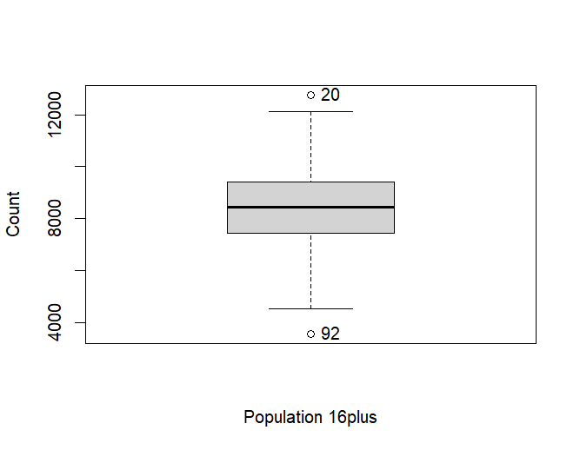

This boxplot shows the outliers in the data, the two points which are outliers is the 20th & 92nd row in the data.

The ward Childs Hill which is part of the London borough of Barnet has a population number which are 16+ as 12761, this is very high, and it Is the 20th row in the data. Also, Darwin which is part of Bromley borough, is the 92nd row in the data which is the other outlier and has a population above 16+ as 3552 which is very low in comparison to most London boroughs.

### Task 6

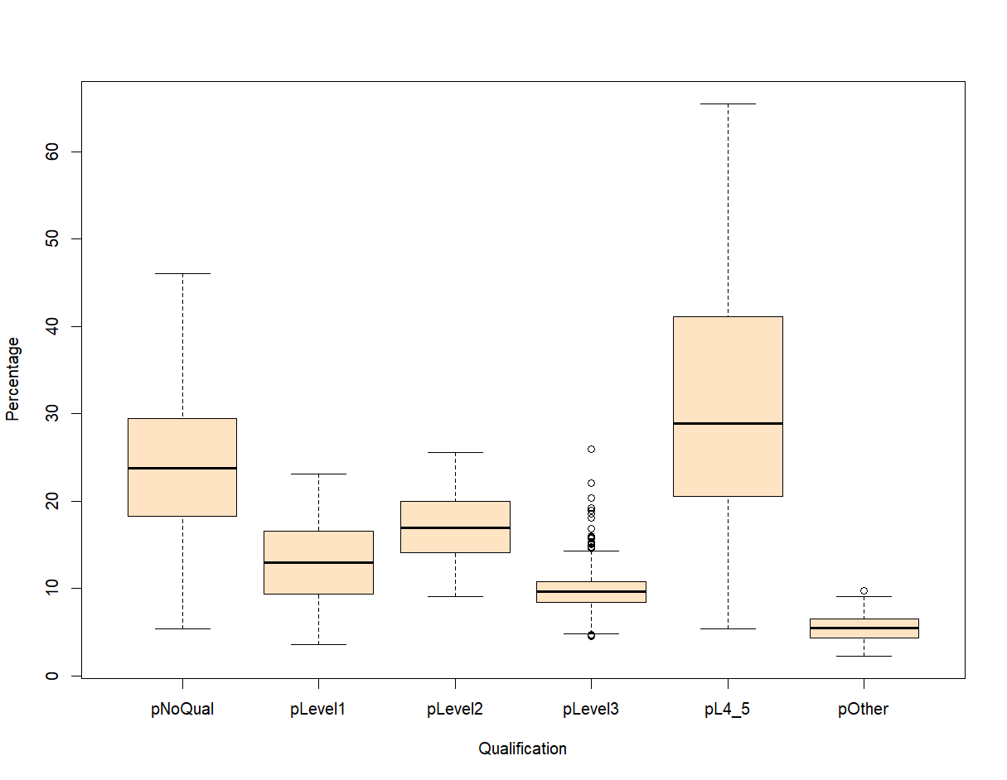

Figure 5 - Highest qualification achieved by people in London

The percentage of people with no qualification in London is normally distributed. This is the case for most qualification levels. However, for Level 3 qualification there is a low number of people with this qualification but there is a lot of outliers.

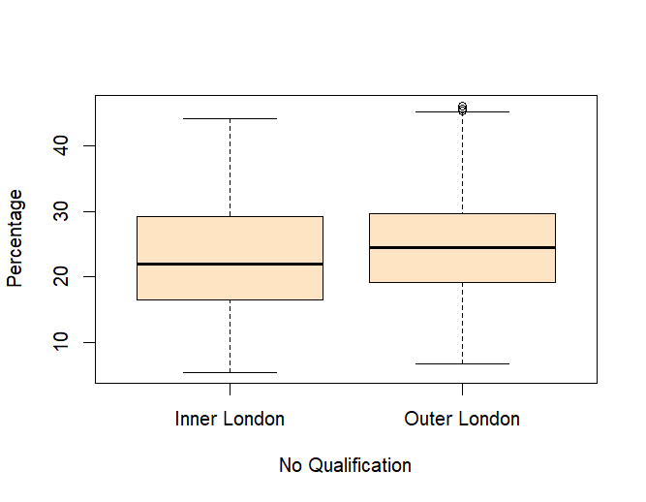

Figure 6 - Boxplot for percentage with no qualification in Inner & Outer London boroughs

When looking at the Inner & Outer London boroughs for no qualifications, it seems to be quite similar.

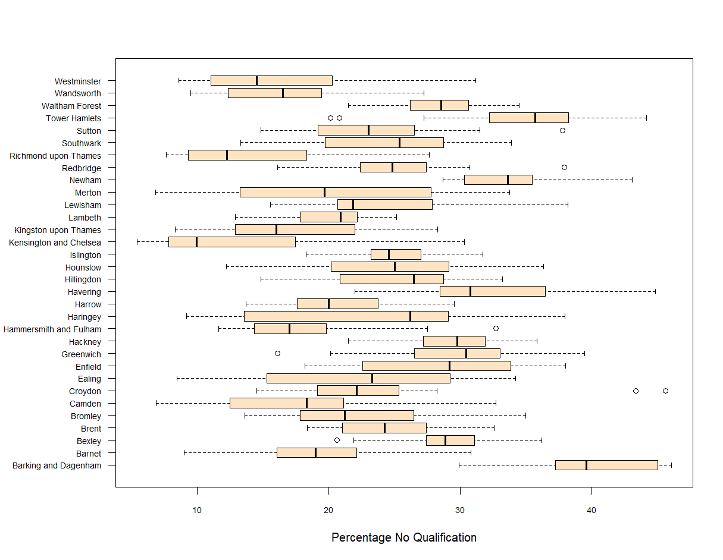

Figure 7 - Boxplot showing percentage of no qualifications for boroughs in London

From this boxplot Barking & Dagenham shows to have a high percentage with no qualifications whereas Kensington & Chelsea shows to have a low percentage with no qualifications. There could be many social factors which lead to this such as crime rate, transport to schools or perhaps the education in Kensington & Chelsea is of a higher level than that in Barking & Dagenham.

### Task 8

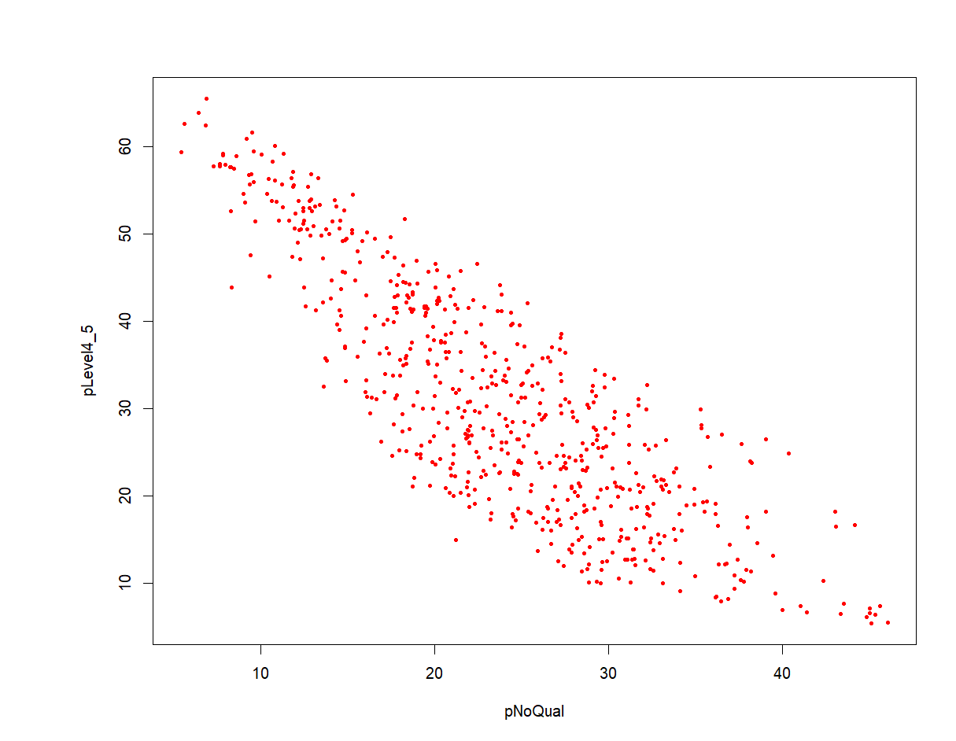

Figure 8 - Scatter plot showing relationship between no qualification & level 4/5 in different wards

There is a strong negative correlation -0.8256637 (Spearman’s) between the two qualifications in each ward. Whereby if there is a ward with high level 4/5 qualifications then it has low number of people with no qualification.

### Task 10

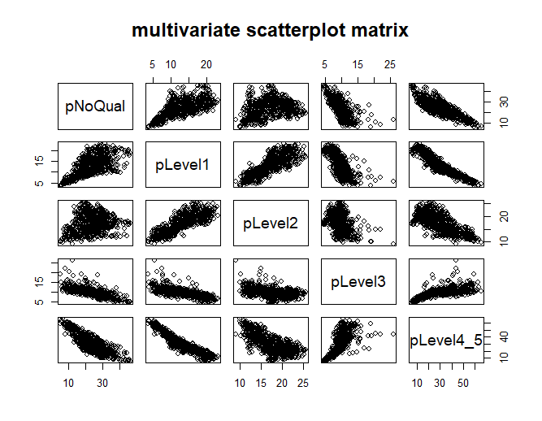

Figure 9 - Multivariate scatter plot matrix

There is a very strong positive correlation of 0.8339219 between people with Level 1 & Level 2 qualifications. A key reason for this is due to schools being mandatory to 16 & under, this is usually when people get these qualifications.

However, there is a strong negative correlation -0.95 between level 1 & level 4/5 qualifications. This may be due to higher education being optional and not everyone wants to go to schools. Also it could be because achieving level 4/5 costs money and may be a factor which influences people in not enrolling to those courses and attaining the level 4/5 qualifications.

## Task 2

### Section 3

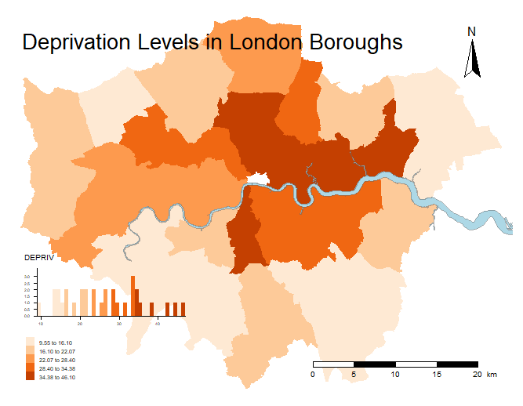

### Task 4

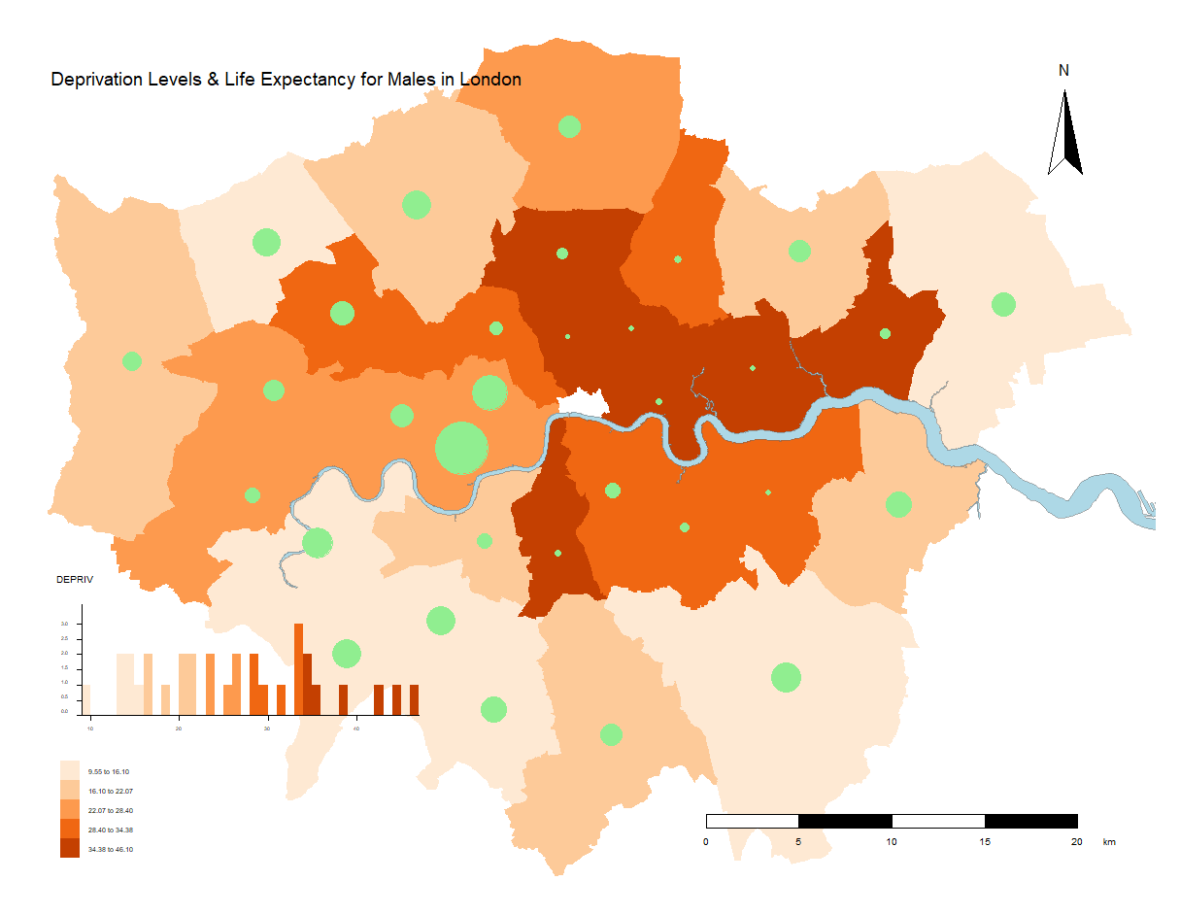

Figure 10 - Map showing deprivation levels for boroughs and life expectancy for males.

This map shows that the inner London boroughs have lower deprivation levels, for example Newham. Also these boroughs show to have lower life expectancy for males too.